Feature - Embeddings

Embedding
The embedding feature enables searching for content based on its meaning. AI can utilize an embedding database to find relevant information and files.
Applications can store embedding data in two types of databases:
1. Microsoft SQL Server - an enterprise-grade database.
Microsoft SQL Server Management Studio (SSMS) - for management and administration.
2. SQLite - the most widely used portable database engine globally.
SQLite Studio - to browse and edit SQLite database files.

Create AI Embeddings Database
For example, let’s say you want to import a folder with company documents into the AI database:
• {AppUserData}\FineTuning\CyberNet Solutions\Documents

Note: By default, the import will assign the Documents root folder name as the group name and the names of subfolders as the group flag (sub-group) for the data in the database. Files in the Documents root folder will be assigned to the . sub-group.
To create an Embeddings Database, go to the [Embeddings] tab.
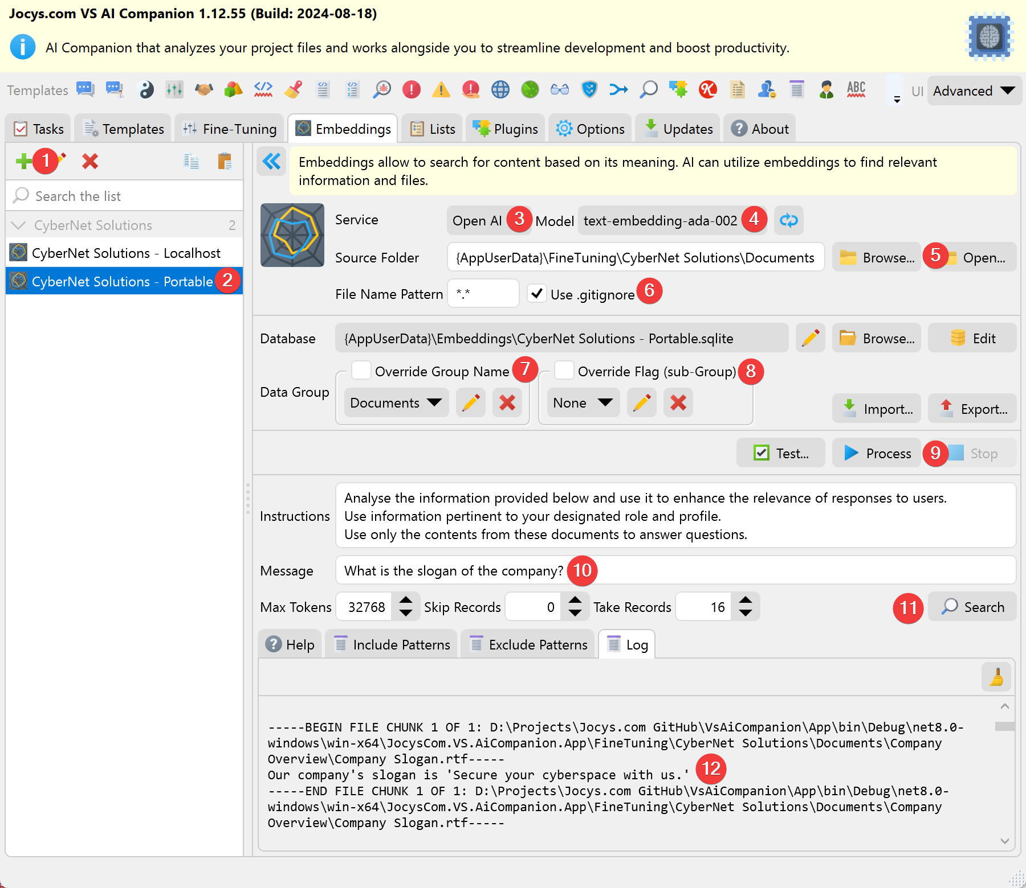
1. Click the [+] button in the list to create a new Embeddings Item.
2. Rename the new Embedding item.
3. Select an AI service.
4. Select an AI embedding model.
5. Browse to the folder containing the context data (text, Word or Excel documents, PDF files, etc.).
6. Optonal: Specify a unique Group Name for your data. Will be used to filter the data during search. Default: Use use the source folder name.
7. Optional: Assign a unique Group Flag (sub-Group). Will be used to filter the data during search. Default: Use use the source sub-folder name.
8. Click the [Process] button.
9. Provide AI Prompt instructions for the data.
Testing:
10. Enter a user message.
11. Click the [Search] button to find the most relevant data to tailor the AI’s answer.

Chat with AI that use Embeddings Database
To create a chat with an embeddings database, follow these steps:
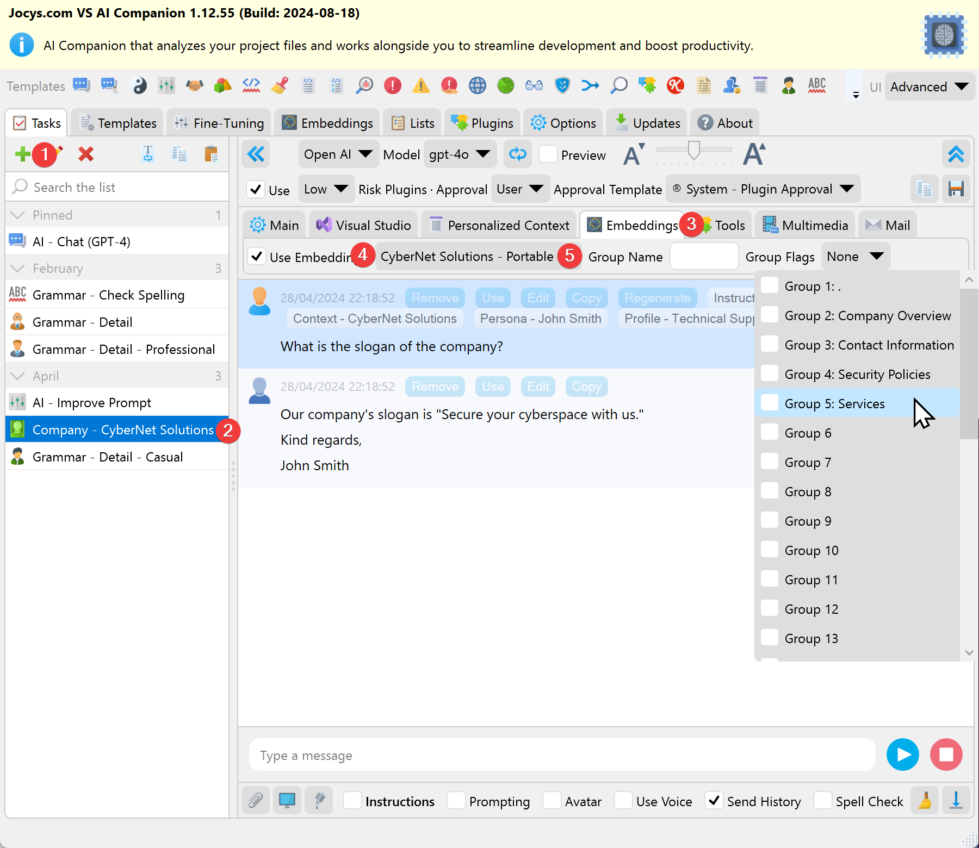
1. Open [Tasks] tab, and click the [+] button in the list to create a new task item.
2. Optional: rename the chat Task item.
3. Inside the Chat panel, select the [Embeddings] tab.
4. Check the box that says [x] Use Embeddings to enable it. Select the Embeddings item from the dropdown list.
5. Optional: Specify search goup name and select sub groups to filter the search data. Default Group Name: Empty, do search on all data groups. Default Group Flag: Empty, do search on all data sub-groups.
From this moment onwards, the app will provide the AI with the most relevant information from the embeddings database for processing.

Tips
You can use this prompt to inform the AI to use the embeddings database for searching:
Utilize embedding search to locate relevant data and enhance the response.

